**Blackboard Writing Audio Recognizer**

**EE474 Term project report**

**Group 5: 임효준, 구인용, 김현지**

**Report by 20160042 구인용**

1. **Introduction**

From our lecture, I learned how to determine a handwritten character using CNN network. The exercise using MNIST dataset made me wonder, what if we’re in a situation where we cannot look over the written letter? A wall or an obstacle may block us from looking at the written character, or sometimes we cannot distinguish a written word because of noisy (dirty) background or overlapped other characters. In these circumstances, we cannot rely on our model using visual data.

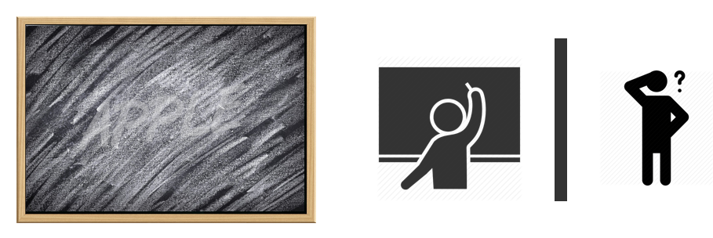

Figure 1 Circumstances where we cannot rely on visual

To resolve this problem, our group suggests a different approach; a handwriting recognizer via auditory information. Since different characters have different shape, motions to write those characters are also different. Thus, a writing sound (relies on writing motion) would be also different. Our hypothesis is that since writing sound of each character is different, we may determine what letter is being written. Writing sound relies on writing tool, so we specified on blackboard writing.

1. **Method**
2. **Data collection**

I (구인용) was in charge of this task.

We agreed to specify our research on upper case English alphabets (‘A’, ‘B’, ‘C’ … ‘Z’). And I collected 5 minutes of writing sound data per letter. Since there are 26 alphabets, it took me more than 2 hours of writing.

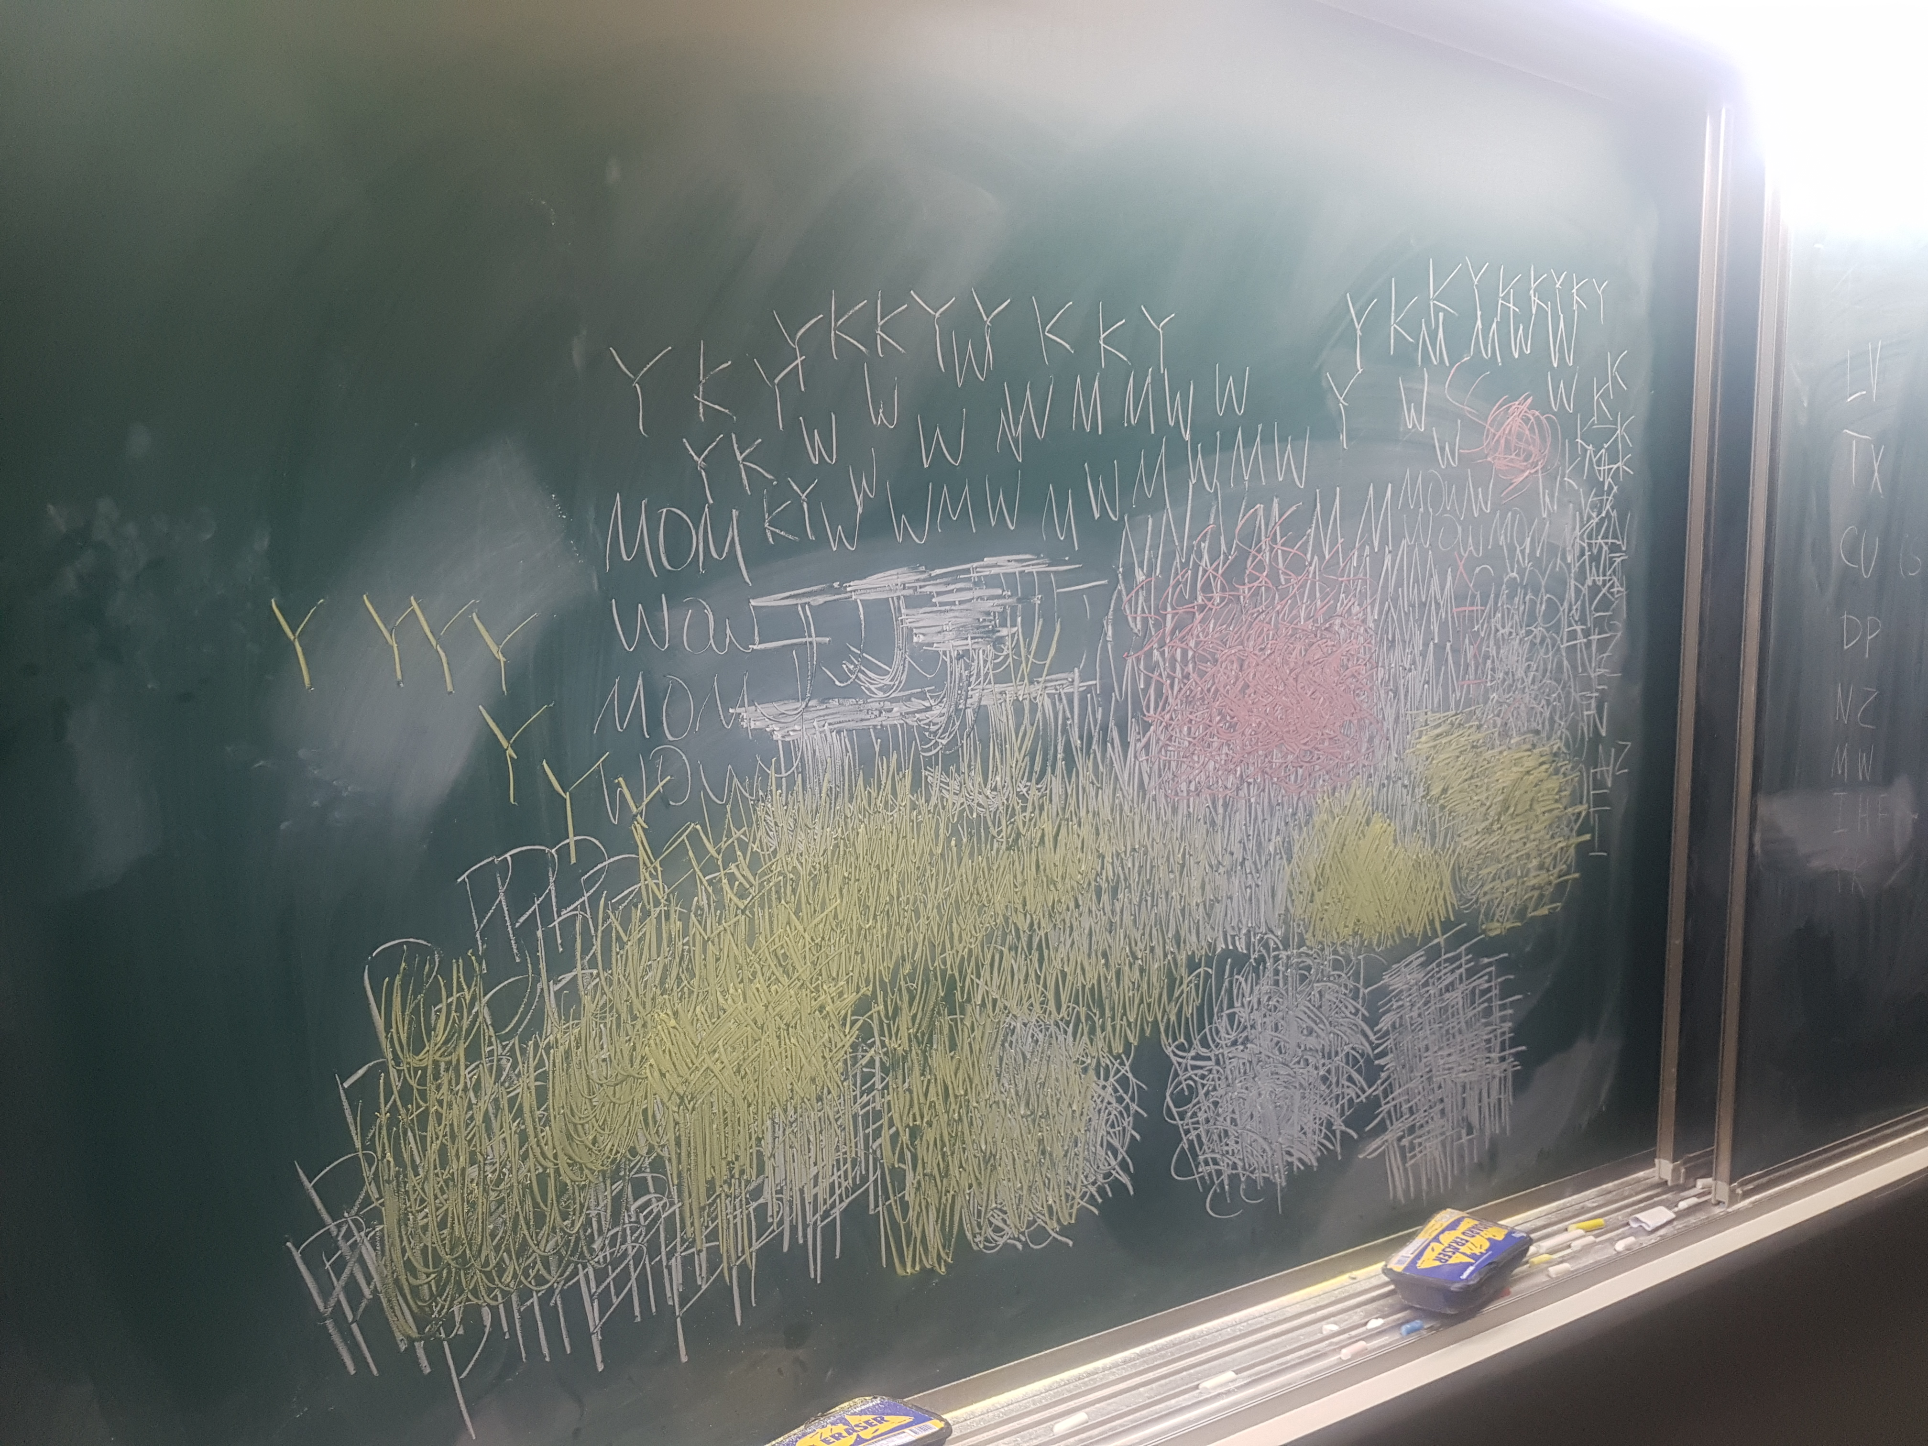

Figure 2 Data collection

1. **Preprocessing**

임효준 was in charge of this task.

He took the data and conduct preprocessing to make input samples for our network. Using Adobe Audition CC, he examined the raw file and split each iteration. Silences were trimmed for each sample. We acquired total 4,179 samples (about 160 samples per letter) for our research. You may check those files on ‘new_atoz.zip’, which is attached to Team leader(임효준)’s mail.

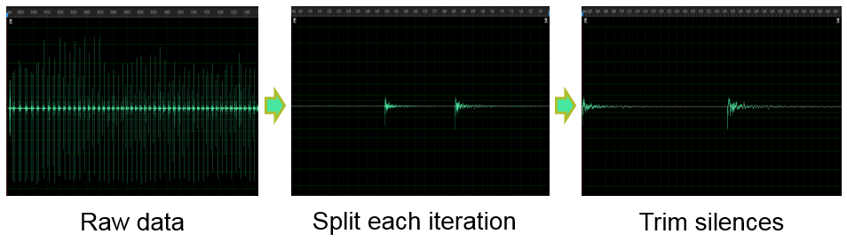

Figure 3 Preprocessing I

The samples are later normalized in amplitude (to range [1, -1]), and in time (by resampling, to 1 second) using python librosa library.

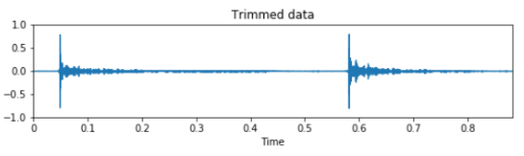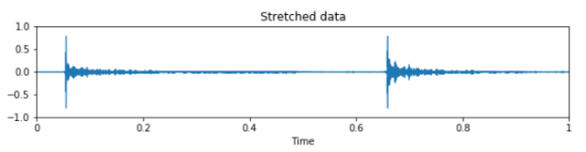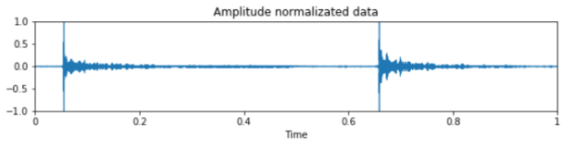

Figure 4 Preprocessing II

1. **Feature Extraction**

김현지 was in charge of this task.

She referred to Karol J.P.’s work (2015) and extracted two features: Spec. and $Δ$. Spec. is log scaled mel-spectrograms. mel-scaled aims to mimic the non-linear human ear perception of sound, by being more discriminative at lower frequencies and less discriminative at higher frequency. $Δ$ feature is local estimate of the derivative of the input data along the selected axis.

She divided each sound clip into (60,41) windows and extracted two features to put it in CNN input. The python code for Feature extraction is as following.

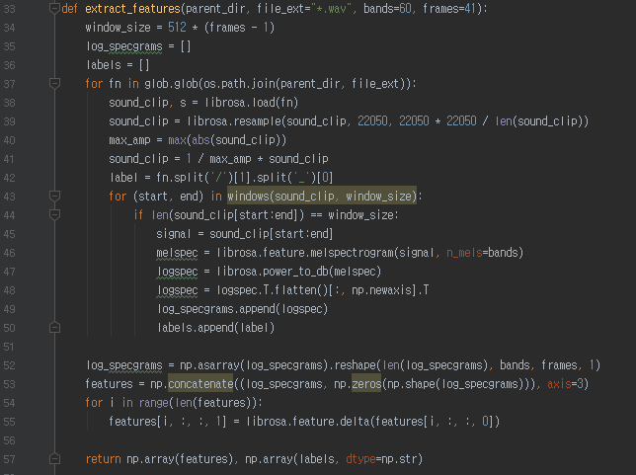

Figure 5 Feature extraction code

Note that sample normalization is conducted on line 39 - 41.

1. **Sound classification**

김현지 was in charge of this task.

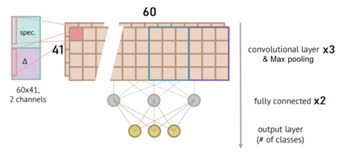

Figure 6 CNN model for sound classification

She modified convolutional neural network (CNN) model model we used in MNIST. Network is constructed of 3 convolution and max pooling layers, and 2 fully connected layers. Softmax cross entropy with logits function was used as loss function, and relu function as activation function. For optimizer, we used adam optimizer, and learning rate was set to 0.008. Please refer to Sound_classification_training.py attached to team leader(임효준)’s mail.

1. **Realtime inference**

임효준 was in charge of this task.

After the network was trained, we wanted to make a real-time recognizer, which infers a character that is being written. Using python pyaudio library, he collected 1 seconds of samples every 50 millisecond. If a letter is detected from a sample, he discarded overlapped contents.

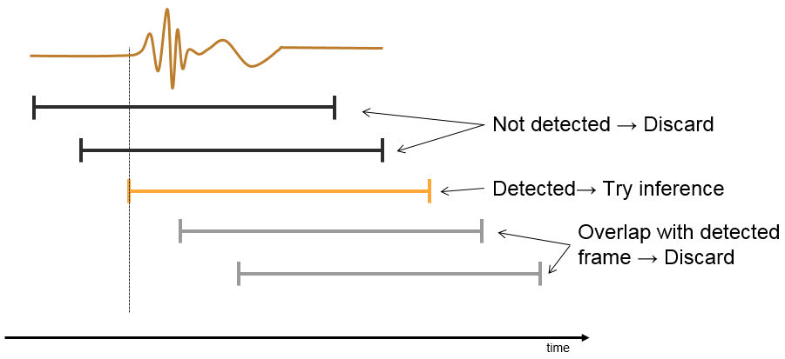

On detected sample, same sound trimming and normalization processing was conducted, before it is used as a test input.

1. **Word validation**

I (구인용) was in charge of this task.

During data collection, I found out that our model has an inevitable limit. For instance, We cannot distinguish character ‘W’ and ‘M’ by sound, because they are are written in similar motion, but only differs its orientation. Similar problem could be found on ‘Z’ and ‘N’, ‘H’ and ‘I’ and et cetera. We needed to improve the performance of our classification, so I suggested a word validation task.

The aim is to double check a written word’s validity by searching the word in dictionary. If a written word is not valid, we may check the next probable prediction result. Our real-time inference interface suggests a predicts a character (prediction), and also gives a letter_softmax vector (1x26) that has probability value for each character. ‘Prediction’ is the element with largest probability.

For a n-letter word, we acquire n vectors of letter_softmax. Thus, we can define an array wordarr, which is n-by-26 array. To explain my algorithm, let me define a ‘Sorted wordarr’, where each letter_softmax is sorted by its probability values. The first element of sorted wordarr would be the ‘prediction’ character, which is ‘the most probable letter’ for its position.

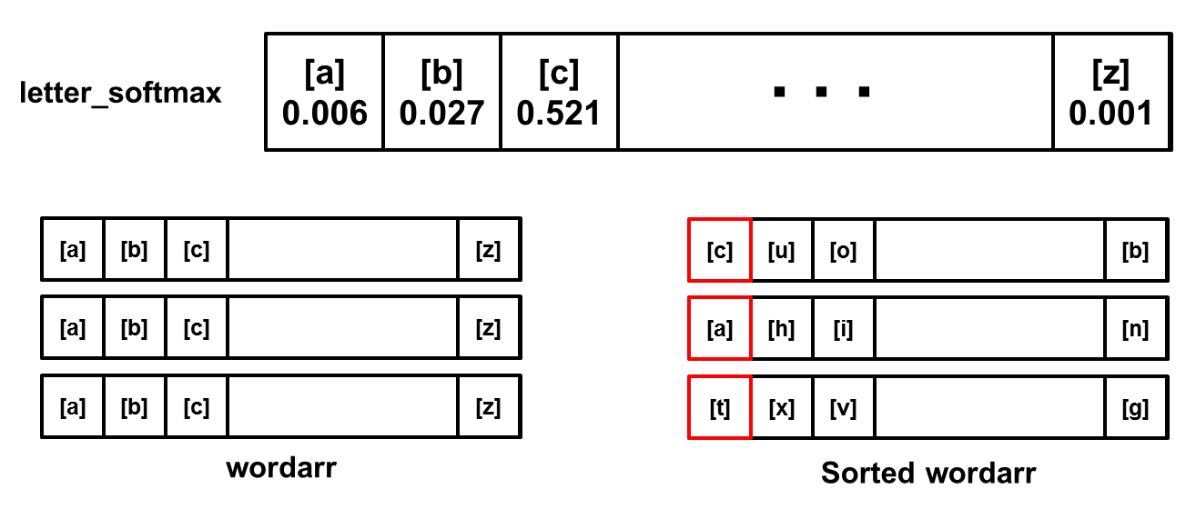

Figure 7 wordarr and sorted wordarr (example)

Above example shows a wordarr and Sorted wordarr for 3-letter word. The prediction for this word would be ‘cat’.

I defined a search rule as follows.

1. Look up the most probable letter combination.
2. Try combinations by changing each letter to next probable letter.
3. Replace the most probable letter that has least probability (a) to next probable letter (b)

(add probability of (a) to probability of (b), and set probability of (a) to zero)

1. Repeat i-iii until there 5 valid words are found

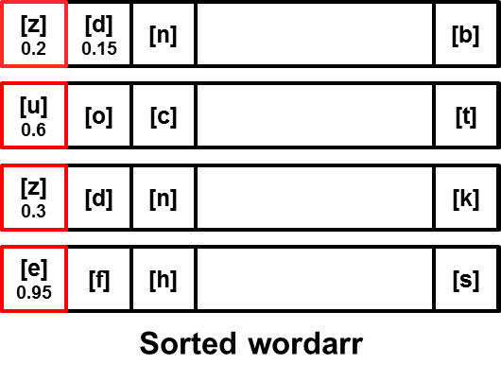

Figure 8 Search rule example

For example, Let us have a sorted wordarr as above. The most probable letter combination is ‘zuze’. Which is not a valid word. (word ‘zuze’ is not in dictionary.) Then, we try combinations by changing each letter to next probable letters. ‘duze’, ‘zoze’, ‘zude’, ‘zuzf’. Such words are not valid also. Then we move on to step iii). The most probable letter that has least probability here is first ‘z’, with 0.2 probability. We set value for ‘z’ to 0, and add 0.2 to next probable letter ‘d’. Now, we have a new sorted wordarr. Let’s go back to step i), and we repeat the search. We will continue checking for word ‘duze’, ‘nuze’, doze’, ‘dude’, ‘duzf’ and so on. By this search rule, we can find valid words like ‘doze’.

I used python pyEnchant package to check if a given word is valid. Following is the python code for word validation with search rule. You can see the full source code for real-time inference and word validation on ‘inference.py’, attached to team leader(임효준)’s mail.

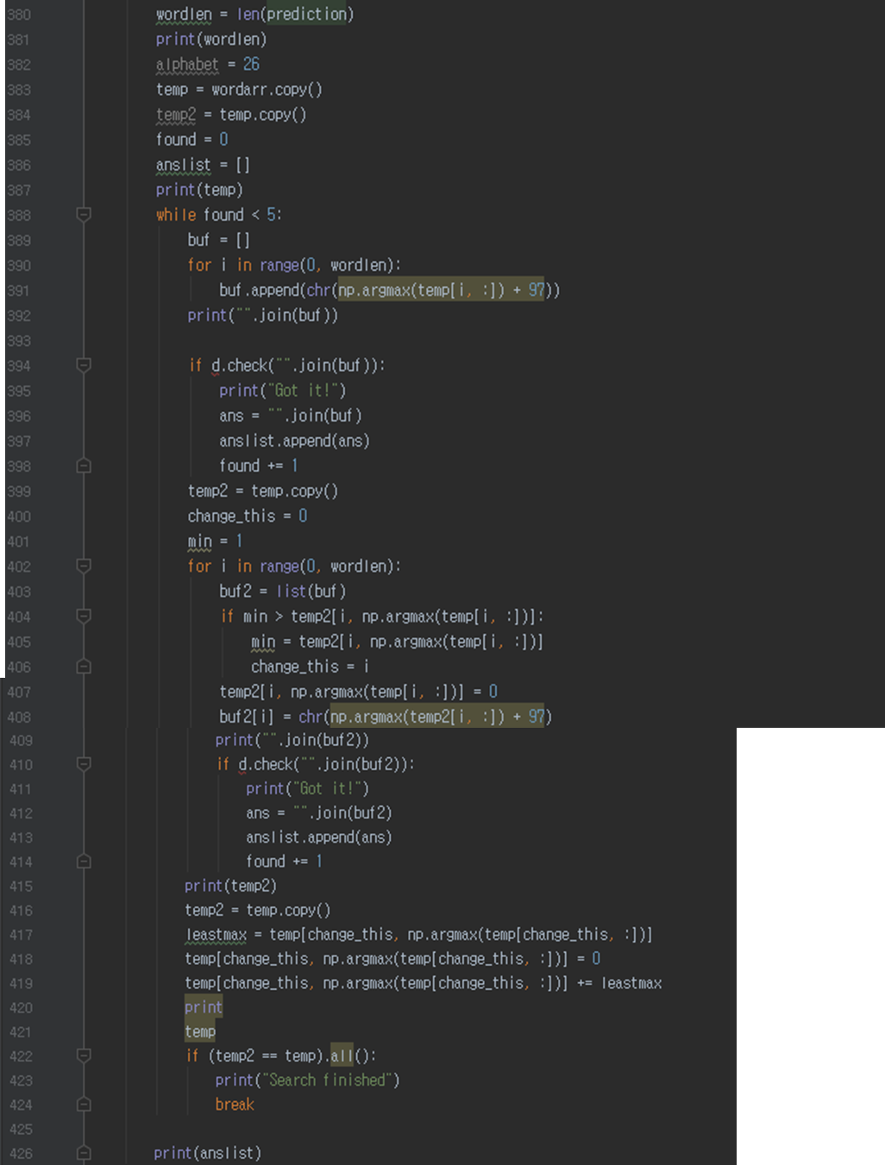

Figure 9 Word validation code

1. **Results**

The training for our CNN network showed cost graph as following.

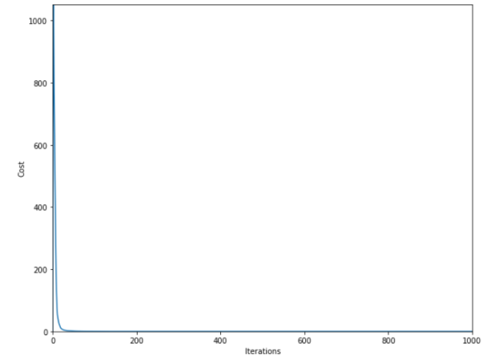

Figure 10 Cost graph

We used 70% of overall data as train data, and 30% as test data. After 1000 iterations, we were able to acquire 100% training accuracy and 86.45% test accuracy.

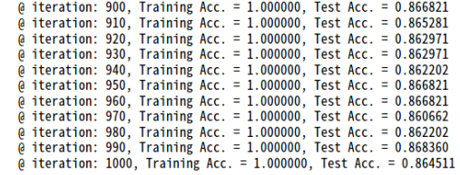

Figure 11 Training and test accuracy

Following snapshots of demonstration videos show how our real-time inference and word validation works. All demo videos are attached in my e-mail.

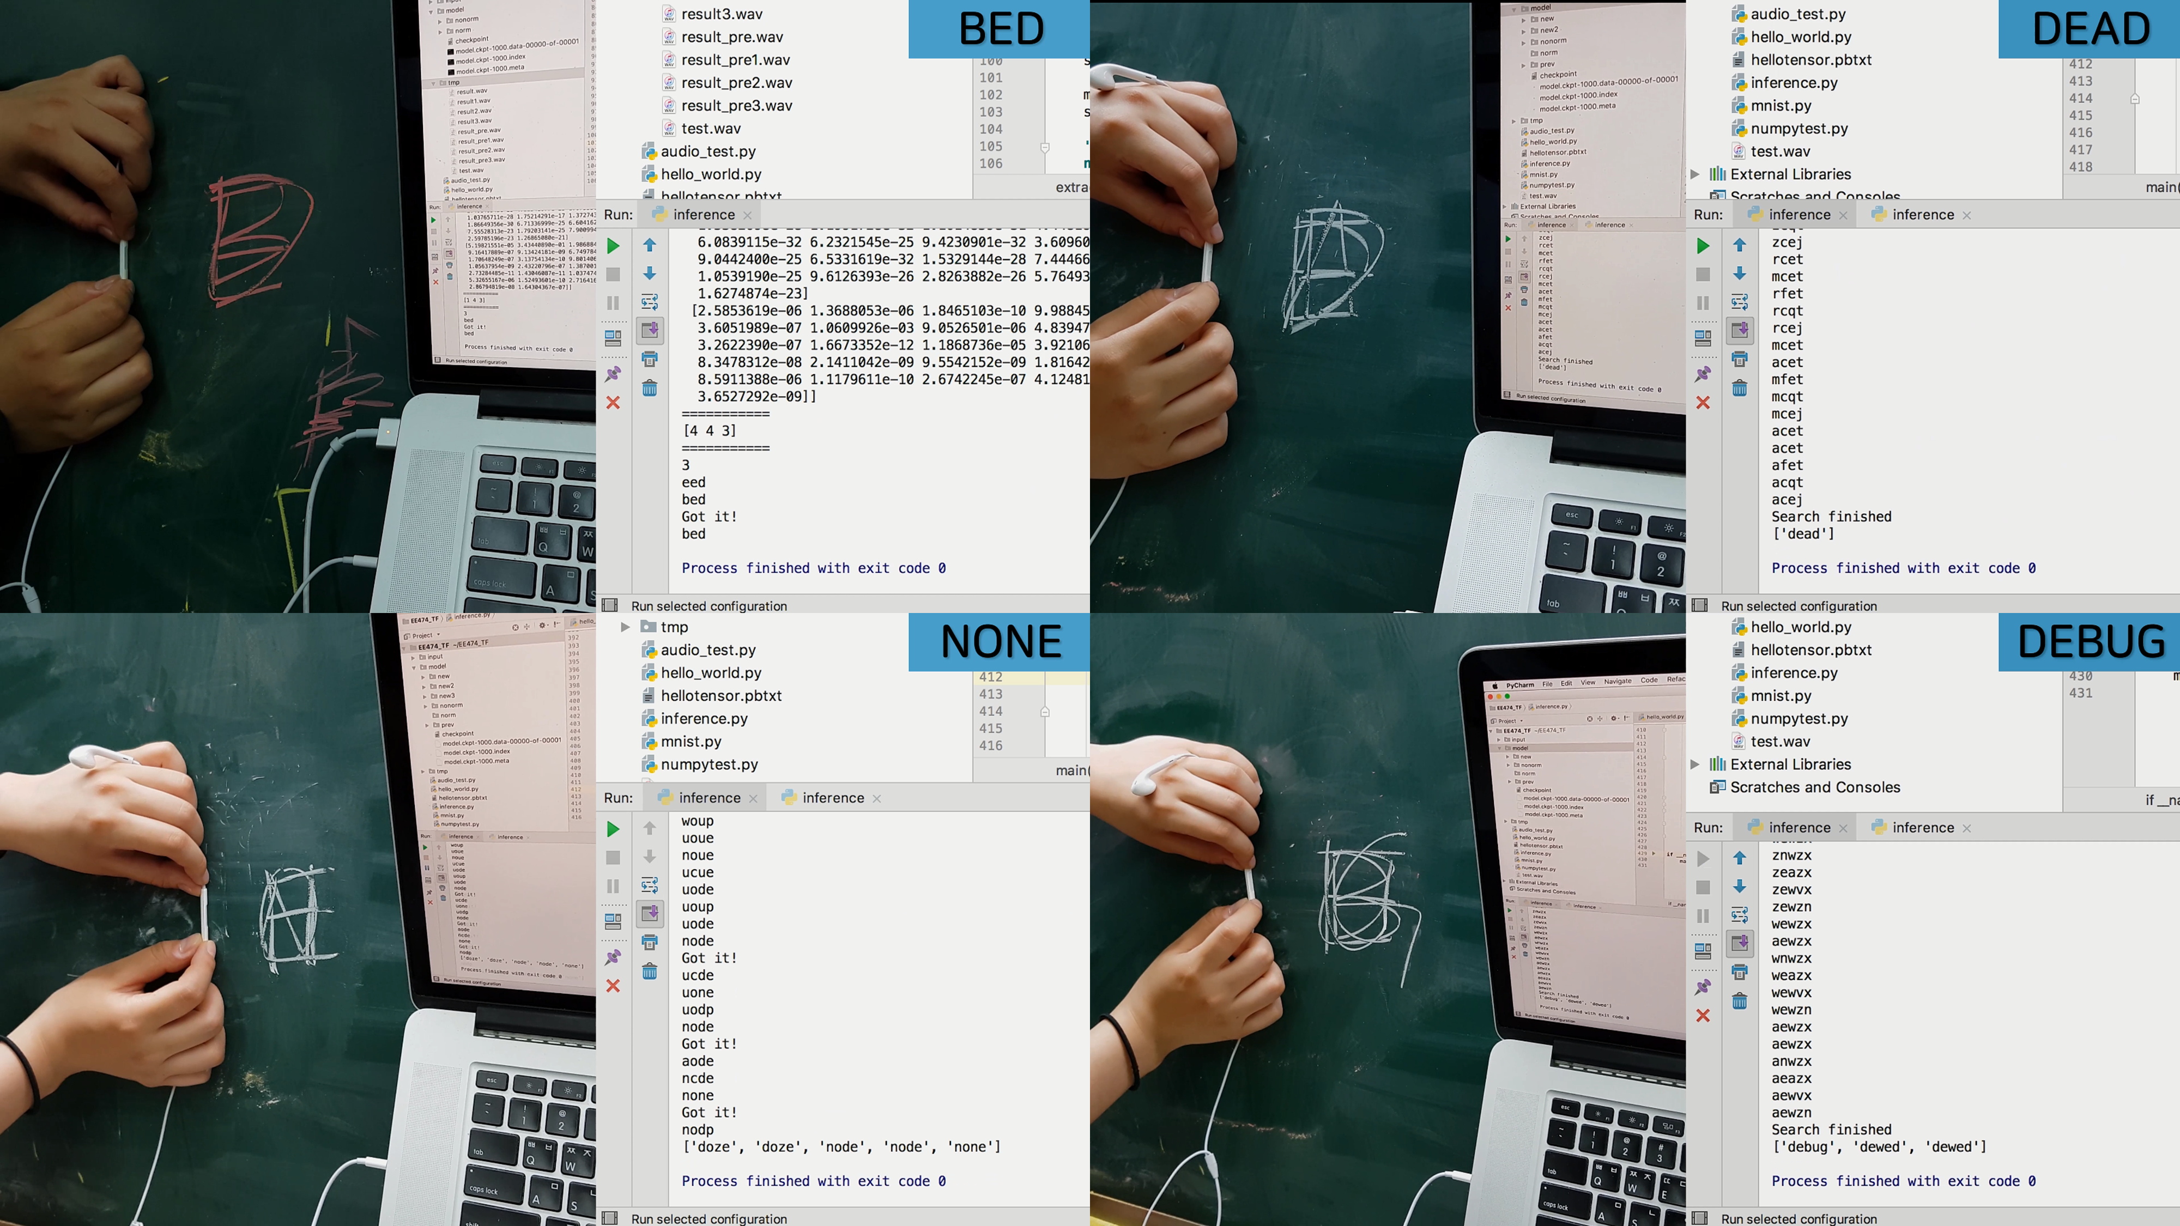

Figure 12 Snapshots of demo video

For “BED” case, word “BED” was written and original prediction resulted “BED”.

For “DEAD” case, word “DEAD” was written and original prediction resulted “DEAD”.

For “NONE” case, word “NONE” was written and original prediction resulted “ZUZE”. Word validation process suggested the correct word “NONE” along the words “DOZE” and “NODE”.

For “DEBUG” case, word “DEBUG” was written and original prediction resulted “GEEOA”. Word validation process suggested the correct word “DEBUG” along the word “DEWED”.

1. **Conclusion**

Though we achieved quite high test accuracy (86.45%) for classifying 26 characters, real-time inference did not show such accuracy. I believe there are several reasons for this difference. First, we did not acquire sufficient number of data. Comparing to MNIST with 60,000 training samples, our data set was not large enough for real-time application. Second, We may have used a better network model. There are other auditory features besides mel-spectrogram and its deltas. There may be a better representation of our samples. Also, using recurrent neural network (RNN) model could be better for our model. RNN is more commonly used for continuous data analysis, such as audio classification. Third, input data could have been spoiled during real-time data collection. Our method shifts 1-second window every 50ms, and front part of data could have been deleted. Lastly, there could be other environmental errors during data acquisition.

Obviously, determining a handwritten word by ‘hearing’ is much more difficult than by ‘reading’, even for human. This is where I believe our approach maintain its worth. If we can improve listed limits, we can have a classifier with better performance compared to human.

I was quite doubtful (would it work?) when I came up with the idea. I was unsure even when I proposed my idea to the teammates. But 휘준 and 현지 agreed that this was an interesting topic, and worked hard on this project. We kept reassuring each other and proceeded our research with optimism. Though we have room for improvement, we were able to acquire a reasonable result. I am proud of what we achieved, and I really enjoyed cooperating with two great colleagues.

From 현지’s work, I learned how to classify audio samples using machine learning model. I learned the concept of mel-spectrogram, and practical usage to acquire such representation using python.

From 휘준’s work, I learned how to handle raw data to fit in our model. I briefly introduced what he’ve done on preprocessing, but his methodology of using Adobe Audition CC was admirable. And his real-time inference interface showed how to manage audio input using python.

I could also learn an important lesson on my part of work, that we can compensate the defect, by using other approach. My word validation algorithm could enhance performance of classifier. Actually, that was the lesson I learned from this project overall; To come up with alternative approach to resolve the problem.

What if we cannot rely on visual on handwriting classifier?

🡪 determine with audio data

What if our classifier shows poor performance?

🡪 Enhance it by applying another algorithm (word validation)

I learned that we may not know the ‘answer’, but can always come up with a ‘solution’. And the practical difficulties can be resolved through good teamwork.